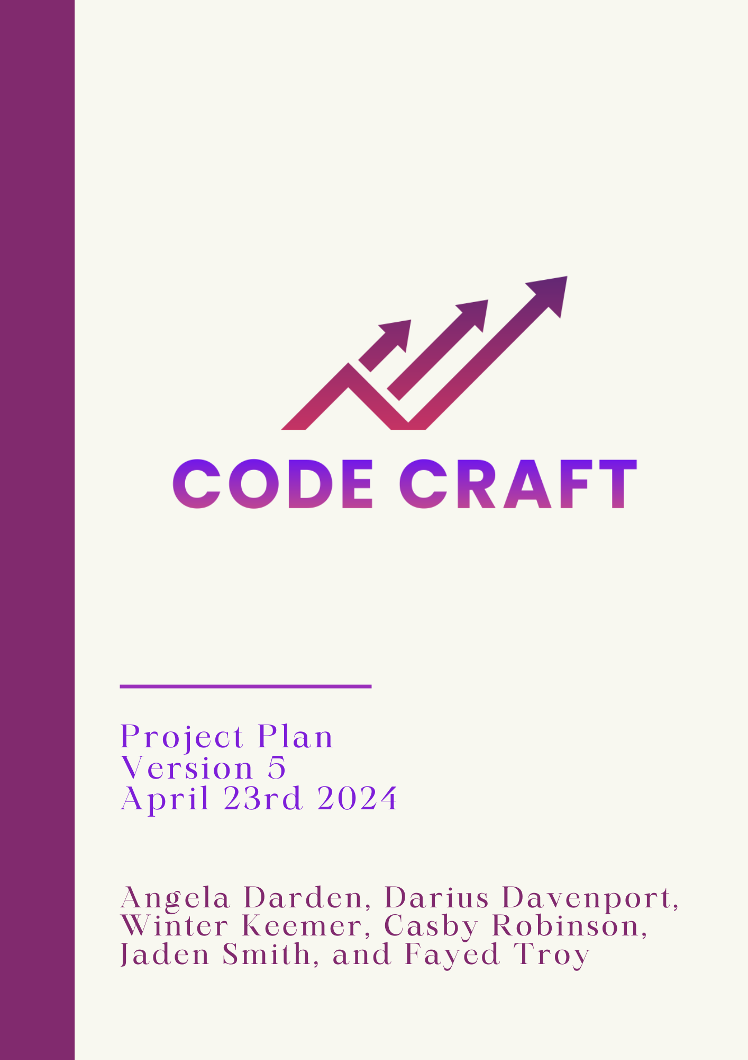

Table of Contents

**1.0 Introduction 2**

1.1 Objective 2

1.2 Scope 2

**2.0 Management 3**

2.1 Communication and Meetings 4

**3.0 Resources 5**

3.1 Software 5

3.2 Hardware 6

**4.0 Schedule 7**

4.1 Iteration 1 (January 11th - January 25th) 7

4.2 Iteration 2 (January 26th - February 15th) 8

4.3 Iteration 3 (February 16th - March 7th) 9

4.4 Iteration 4 (March 8th - March 28th) 10

4.5 Iteration 5 (March 29th - April 23rd) 11

4.6 Final Presentation & Demonstration (April 24th - April 30th) 12

**5.0 Risk Management 13**

5.1 Key Infrastructure 13

Software 13

5.2 Predicted Threats 13

5.3 Vulnerabilities and Risks 13

**6.0 Restrictions, Limitations, & Constraints 14**

6.1 Restrictions 14

6.2 Limitations 14

6.3 Constraints 14

**7.0 Revision Log 15**

# 

# 

# 1.0 Introduction

## 1.1 Objective

Our group goal is to create a bot that would advise them to understand the stock trading world. The bot should run on a trading strategy algorithm that will advise the user on the current stock to whether they should trade it, buy it, or sell it. The bot should work as an extension of Alpaca.

## 1.2 Scope

The team has been given a synopsis of the tasks they must complete to create an application for computerized stock trading:

* A Trend Trading Algorithm
* Data acquired from Alpaca
* Alpaca (our Internet Trading Platform used to simulate a real trading platform)

The software project is being undertaken to develop a stock trading application based upon an algorithm using data acquired from a(n) Trend Trading strategy. Our application will be executed any day from 9:30 am to 4:00 pm. Using Alpaca as our Internet Trading Platform, Code Craft will be funded $100,000 to use for our stock trading application. Project deliverables include documentation, individual and group timesheets and contributions, meeting minutes, and the software application itself. The group, Code Craft, will review and approve final documentation and application status before publishing. This project will not include option trading, and will only take a long or short position in a stock.

# 2.0 Management

Everyone in the group has been assigned their own role and deliverables to complete. When assigning, everyone’s strengths and weaknesses were considered when deciding who would be assigned to what role. Casby Robinson was appointed as Project Manager (PM) by Dr. Muhammad and Dr. Chittenden and Fayed Troy was assigned to be Assistant Project Manager. We further split up the roles into Programming Leads, Documents Leads, and Data Analyst Lead, and Version Control Lead. While the goal is to get everyone to touch a part of every part of this project, we thought it would be beneficial to assign people as Leads to whatever they wanted to manage.

| Role | Members Assigned | Description |
| --- | --- | --- |
| Project Manager | Casby Robinson | Ensures deliverables are completed on time and making sure team performs at an optimal level |
| Assistant Project Manager | Fayed Troy | Second in command to ensure deliverables are completed and helps with team performance |
| Programming Leads | Darius Davenport and Angela Darden | Coordinators for programming matters |
| Document Leads | Everyone | Documents how to use the program |
| Data Analyst Lead | Jaden Smith | Coordinator for research and collecting data |
| Version Control Lead | Winter Keemer | Before every iteration, she will revise every document to see if it is up to par for submission |

## 2.1 Communication and Meetings

We will conduct weekly in-person meetings and communication through group messages.

1. Weekly Meetings: Weekly meetings will be held 2-3 times a week based on the project’s necessities. Meetings are being held from 10AM - 11AM on Monday and Wednesday. All team members: Jaden Smith, Fayed Troy, Casby Robinson, Winter Keemer, Darius Davenport, and Angela Darden are expected to attend the group meetings where we will work together on enhancing the product and documentation. All in person group meetings will be held in S&T Rm. 127.
2. Group messaging: Team members will communicate with updates, scheduling, and reminders via iMessage.

# 3.0 Resources

## 3.1 Software

To effectively complete this project, we needed a multitude of tools. As this is a group project, we needed development software and collaboration software. This is especially important to make sure deliverables are completed early/on time.

Software we are going to utilize:

| Tools | Descriptions |
| --- | --- |
| Github | GitHub will be used to host and update our source code as the tasks are completed. Also, this will be used to allow all team members to easily access the source code as needed. |
| Google Drive | Google Drive is a cloud storage service that lets users store and synchronize digital content across computers (Time sheets, Project Plan, Presentation, and Evaluation) |
| Jira | An issue tracking product that allows bug tracking, agile, project management and work management. |
| Visual Studios Code | Visual Studio Code is a source code editor that we chose to use to make edits to the existing code. |
| Python | Object-oriented programming language we are using to code the application. |
| Alpaca | Alpaca trading is a modern financial platform that provides users with seamless access to algorithmic trading and investing through an API-first approach. With a focus on democratizing financial markets, Alpaca offers commission-free trading, robust tools for developing and executing trading algorithms, and easy integration with various financial data sources. |

## 

## 3.2 Hardware

The hardware utilized through the development of the project will be listed here.

| Tools | Descriptions |
| --- | --- |
| Laptops | Personal use devices allowing us to collaborate from various locations |
| Cellphones | Cellular device allow us to communicate with each other from long distances |

# 

# 4.0 Schedule

## 4.1 Iteration 1 (January 11th - January 25th)

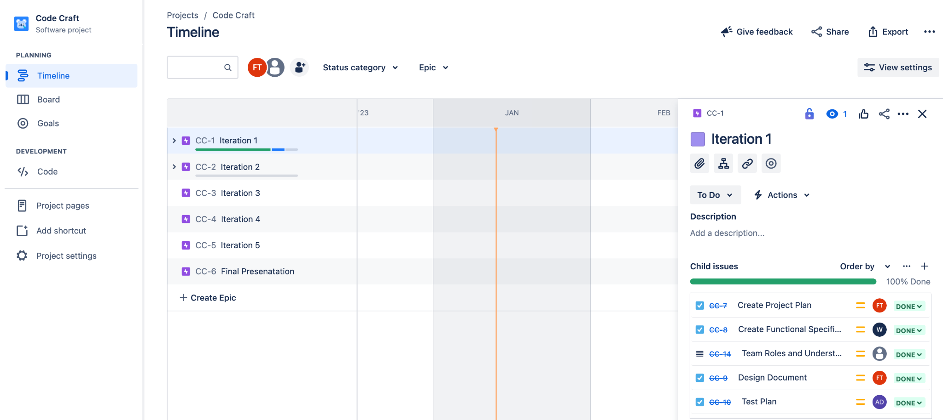

* Create and work on documents
* Assign team roles and objective
* See what team members strengths and weaknesses are
* Prepare and give a presentation outlining what are plan in
* Create a board on Jira to track progress and work that needs to be completed
* Established trading strategy
* Check timesheets

## 4.2 Iteration 2 (January 26th - February 15th)

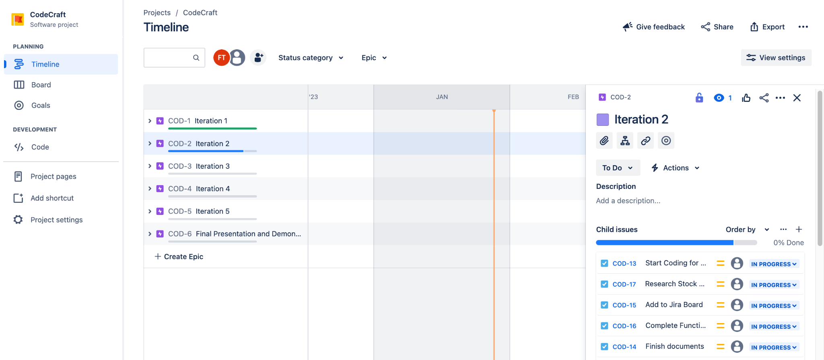

* Start Coding for Interface and Bot
* Finish documents
* Add to Jira Board
* Research Stock portfolios and data
* Check timesheets
* Complete Functional Documents
* Start Interface

## 4.3 Iteration 3 (February 16th - March 7th)

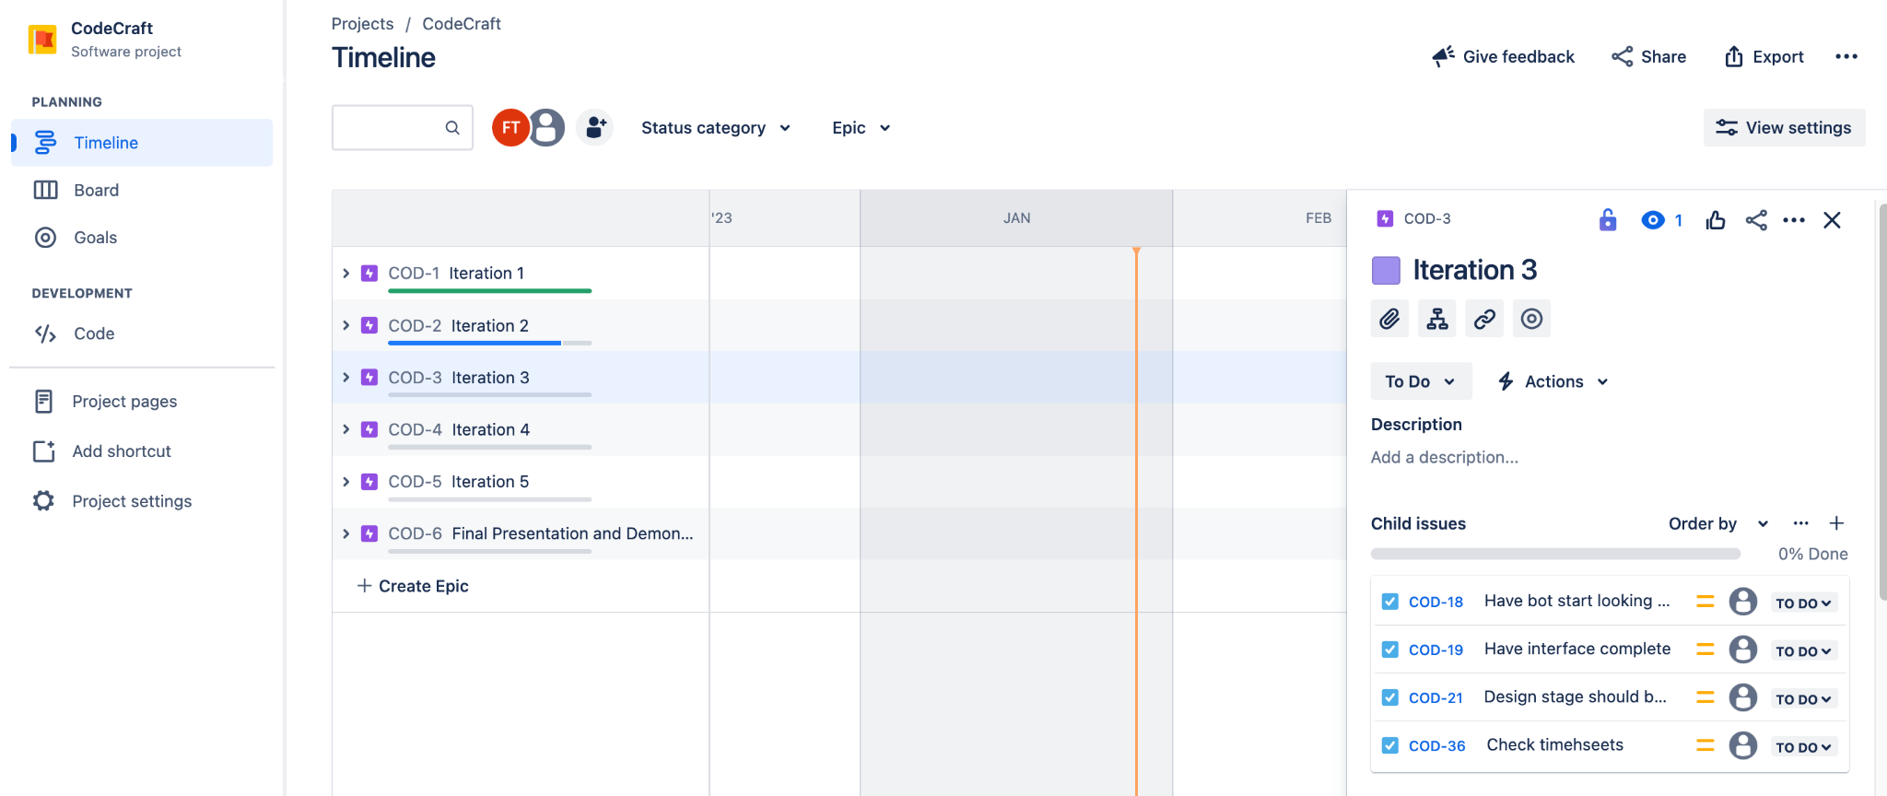

* Have bot start looking at stocks to invest in and try to enable it to trade
* Have interface complete
* Design stage should be finished
* Check Timesheets

## 4.4 Iteration 4 (March 8th - March 28th)

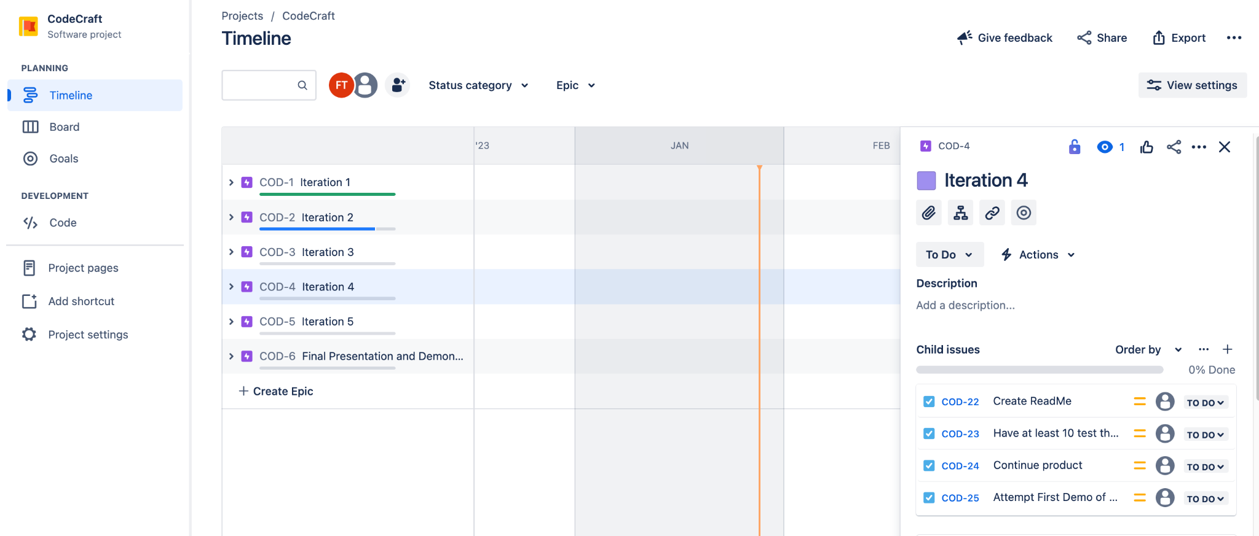

* Create ReadMe
* Have at least 10 test throughout the iteration to see what needs to be fixed or changed
* Continue product
* Attempt First Demo of Product

## 4.5 Iteration 5 (March 29th - April 23rd)

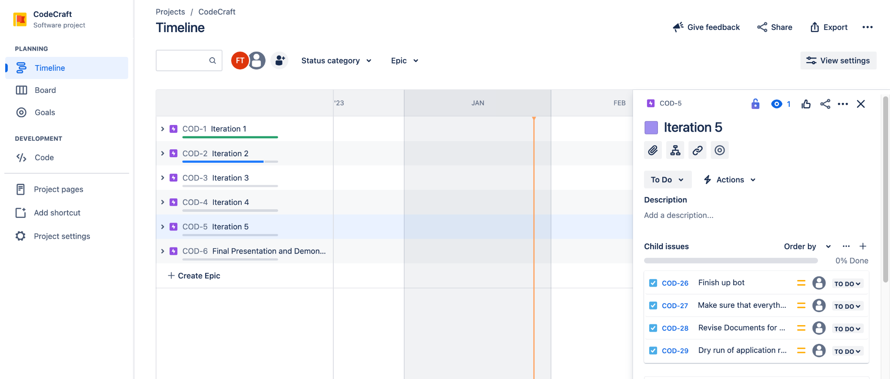

* Finish up bot
* Finalize algorithm
* Make sure that it consist of everything the client ask for
* Revise Documents
* Dry run of application running before last iteration

## 4.6 Final Presentation & Demonstration (April 24th - April 30th)

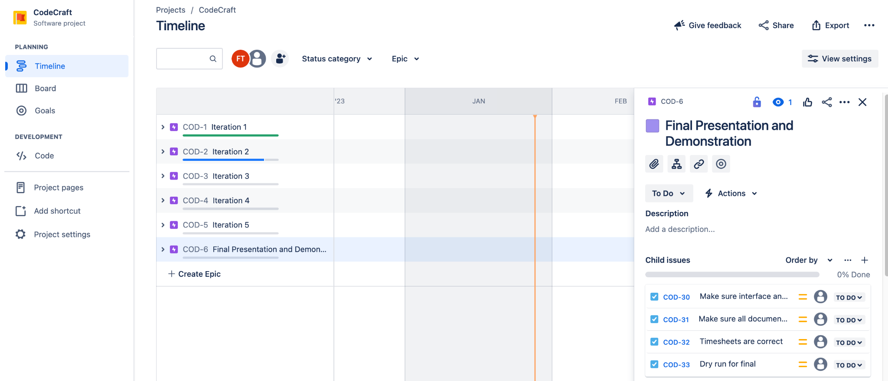

* Make sure interface and code is at its best
* Make sure all documents are up to date
* Timesheets are correct
* Dry run for final

# 

# 5.0 Risk Management

As with any project, there are going to be risks involved and we wanted to address these and mitigate them as best as possible. This will expand upon the details on the risks involved, impact on project, and how to mitigate each risk best.

## 5.1 Key Infrastructure

## Software

* Visual Studios
* Google Drive
* Jira (forecasting)

Hardware

* Personal Computers

## 5.2 Predicted Threats

* Computer Exposure
* Cyber Attacks
* Stock Changes

## 5.3 Vulnerabilities and Risks

Vulnerabilities

* None

Risks

* The market is open from 9:30 and closes at 4:30 if you missed your window to buy or sell stocks

# 6.0 Restrictions, Limitations, & Constraints

## 

## 6.1 Restrictions

* *Time:* The stock market is only open from 9:30am- 4pm. It restricts the group from viewing the trends of companies chosen in the morning and at night as well.

## 6.2 Limitations

* Ensuring the completion of all tasks before the scheduled delivery date may result in certain elements being incomplete or hastily done due to the tight time constraints.

## 6.3 Constraints

* *Experience:* Not everyone on our team is equally experienced in Python, which could potentially slow us down. However, having different levels of expertise in Python and probabilities might actually benefit our team. We can assign tasks based on individual skills, allowing us to divide and conquer our work more efficiently.
* *Time:* To meet our project's deadline, we're using timesheets to keep our team organized and on schedule. Some team members, who are familiar with Python, are dividing the coding tasks among themselves to ensure efficient completion of the project.

# 

# 7.0 Revision Log

| Revision | By | Date | Description |
| --- | --- | --- | --- |
| 1.0 | Code Craft | 01/26/2024 | Project Plan for Iteration 2. |
| 2.0 | Code Craft | 02/15/2024 | Project Plan for Iteration 3. |
| 3.0 | Code Craft | 03/07/2024 | Project Plan for Iteration 4 |
| 4.0 | Code Craft | 03/28/2024 | Project Plan for Iteration 5. |
| 5.0 | Code Craft | 04/23/2024 | Project Plan for Final Presentation. |